User Guide: Spike Detection GUI

Table of Contents

**Overview** 2

**Getting Started** 3

**Select** **Spike** **GUI** **Figure** 4

**Zoom** **into a** **burst** 5

**Find** **the Spike Times using the Algorithm** 6

**Adding Spike Times using the Algorithm** 7

**Manually Remove a Spike** 8

**Manually** **Add** **a Spike**. 9

**Re-plot** **Peak Labels** 10

**Set an Alignment Spike** 11

**Save** **Burst** 12

**Compare** **Bursts** 13

**Edit** **and** **Delete** **Bursts** 14

**Save** **Spike** **Times** 15

**Close** **GUI** 16

**Load Spike Times** 17

# **Overview**

The spike detection graphical user interface allows users to detect spike times manually and automatically. This GUI was used to find epileptic seizure spikes from neural recordings of organotypic hippocampal slices.

This user guide includes step by step instructions for running the Spike Detection algorithm posted on github (<https://github.com/Chris-Dussourd/Epilepsy-Jitter-Code>).

Start by downloading the spike detection GUI and downloading the supporting files. Open and run the “Seizure_Detection_And_Jitter_Analysis_Main.m”. Make sure the support .m and .fig files are in the same folder as your main file.

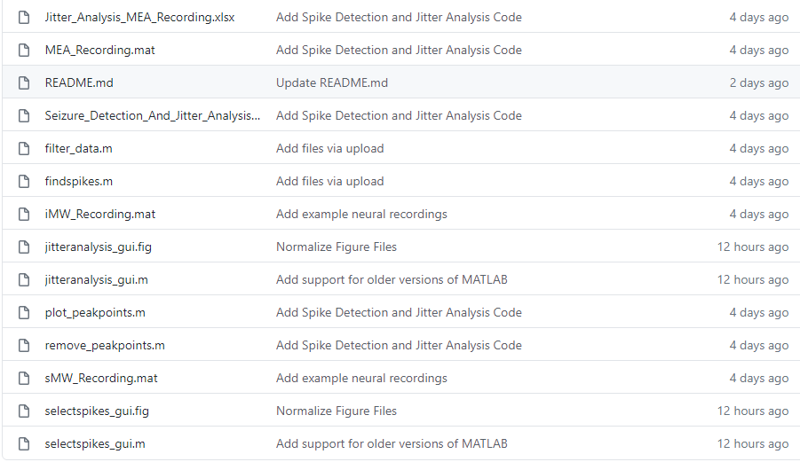

# **Getting Started**

After running “Seizure_Detection_And_Jitter_Analysis_Main.m”, a prompt will appear to browse to a file containing the electrical recording data. In the picture below, we selected the MEA_recording.mat file located on github.

* To create your own recording MATLAB file. Save a channel variable containing the recording data and a scanFreq variable containing the sampling frequency.
* save(‘Example_Recording.mat','channel','scanFreq')

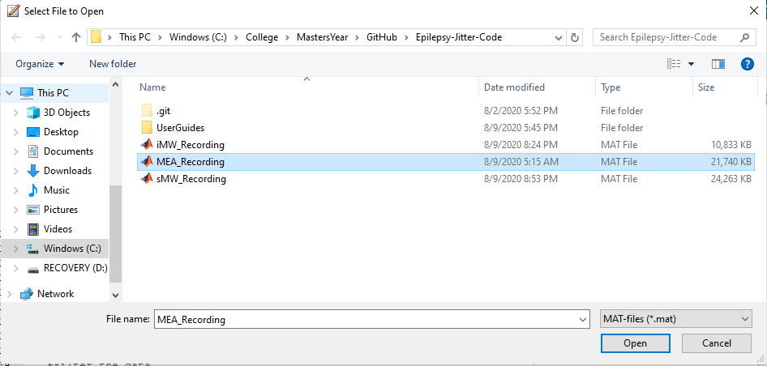

A prompt asking for spike time data will appear.

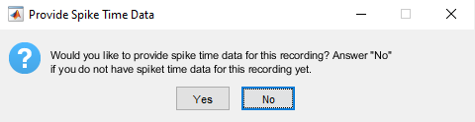

Click No for now. For more information on loading spike time data, go to step 13.

# The select spike GUI will appear.

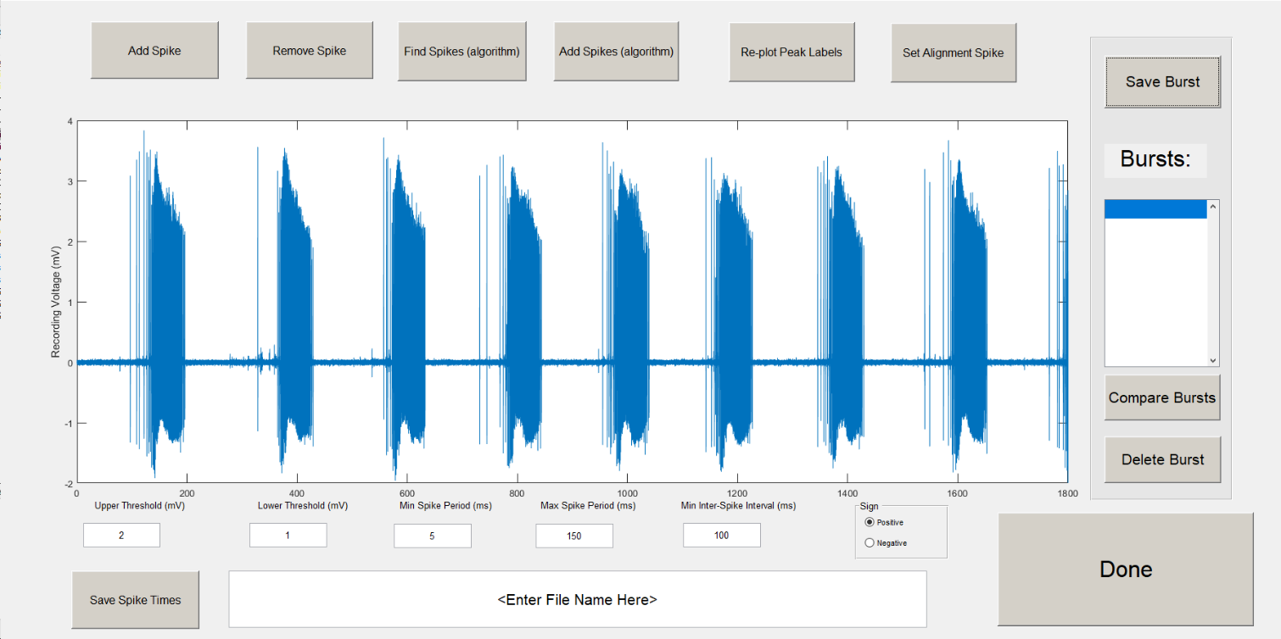

Manually

Add Spike

Manually

Remove Spike

Remove unsaved spikes and use algorithm to find new ones

Keep Spikes and use algorithm to find new ones

Replot spike labels if chart gets moved or message box pops up

Set alignment spike to align with other bursts

Save spike times into the burst listbox

Save spike times into an excel document with this file name

Close Spike Detection GUI

Delete bursts from listbox. Erases data not already saved into an excel file.

Plots the bursts selected in the listbox with their spike times aligned using the alignment spike

**Parameters used for spike detection GUI:**

Upper Threshold - voltage values above this threshold will be candidates for spikes.

Lower Threshold - voltage values that cross this threshold are used to determine spike period (first time it crosses is beginning of spike and second time it crosses is the end of this spike)

Max Spike Period – only spikes lasting less than this period will be selected

Min Spike Period – only spikes lasting at least as long as this period will be selected

Min Inter-Spike Interval – the beginning of a new spike must be this time period away from the end of the previous spike

Sign – use the algorithm to find spikes in the positive or negative direction

**Steps to use the Graphical User Interface**

**Steps for interacting with the GUI**

# Zoom into a burst

Mouse over the figure window and click the zoom button.

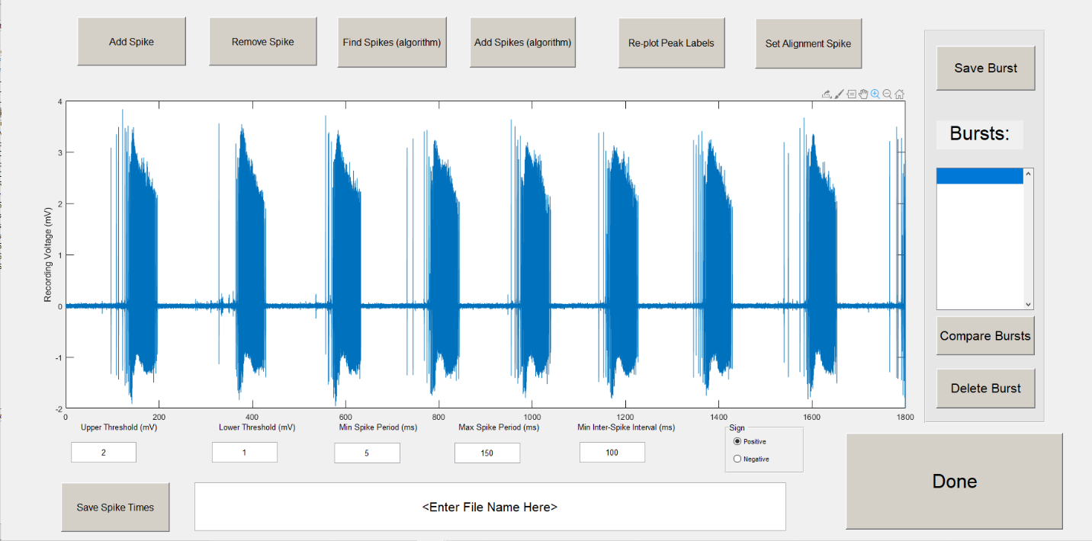

Click and drag over the burst you want to analyze.

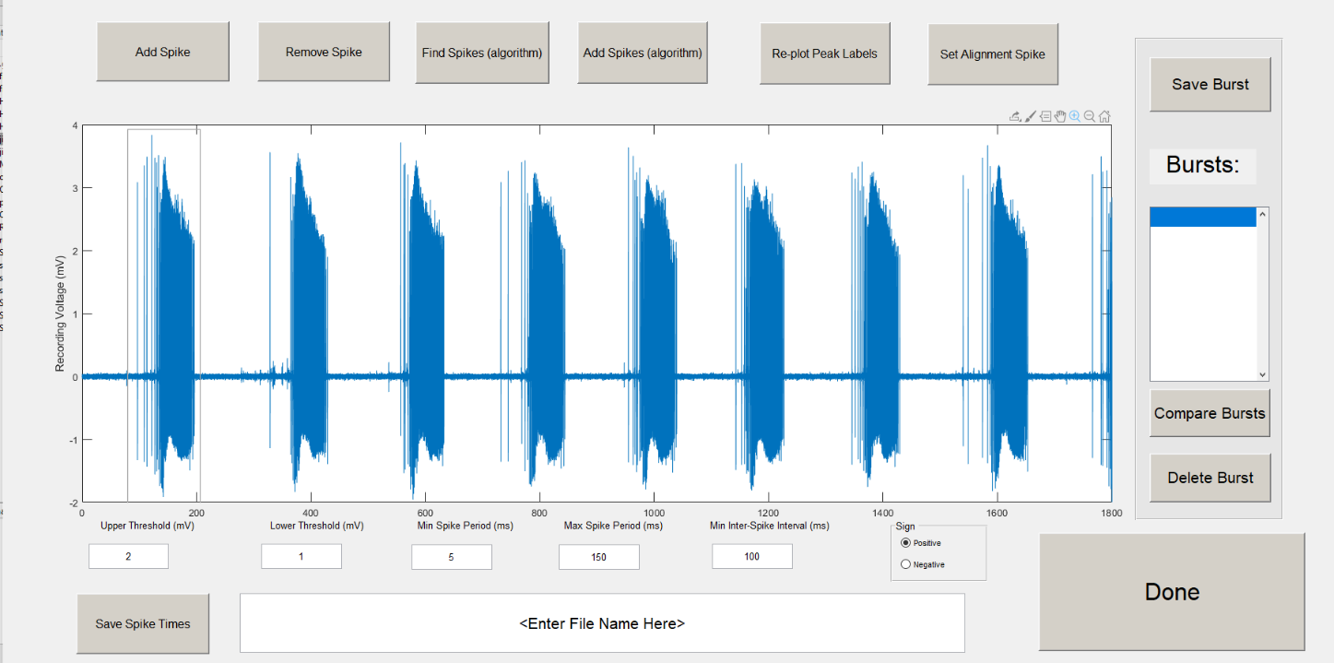

# Find the spike times using the algorithm

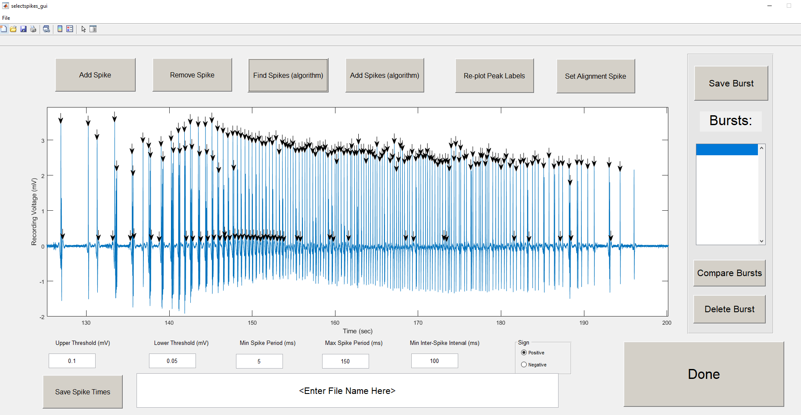

If your parameters do not fit the data well, you can adjust them and click find spikes again. It will delete unsaved spike time data and run the spike detection algorithm again.

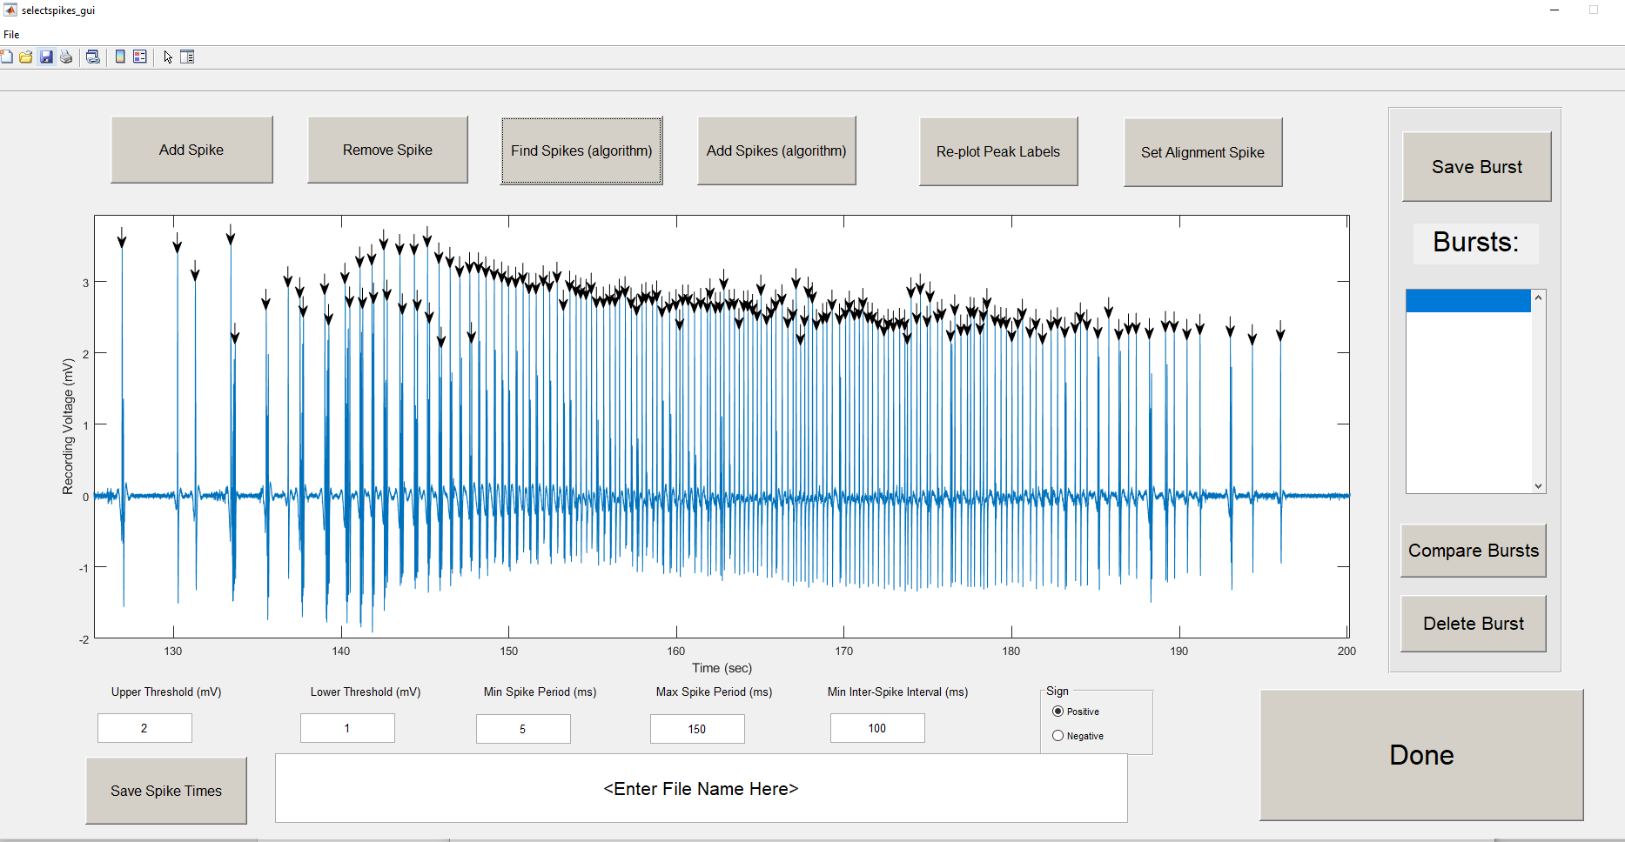

# Adding Spikes button uses the same algorithm as the find spikes button except it keeps the previously unsaved spike times.

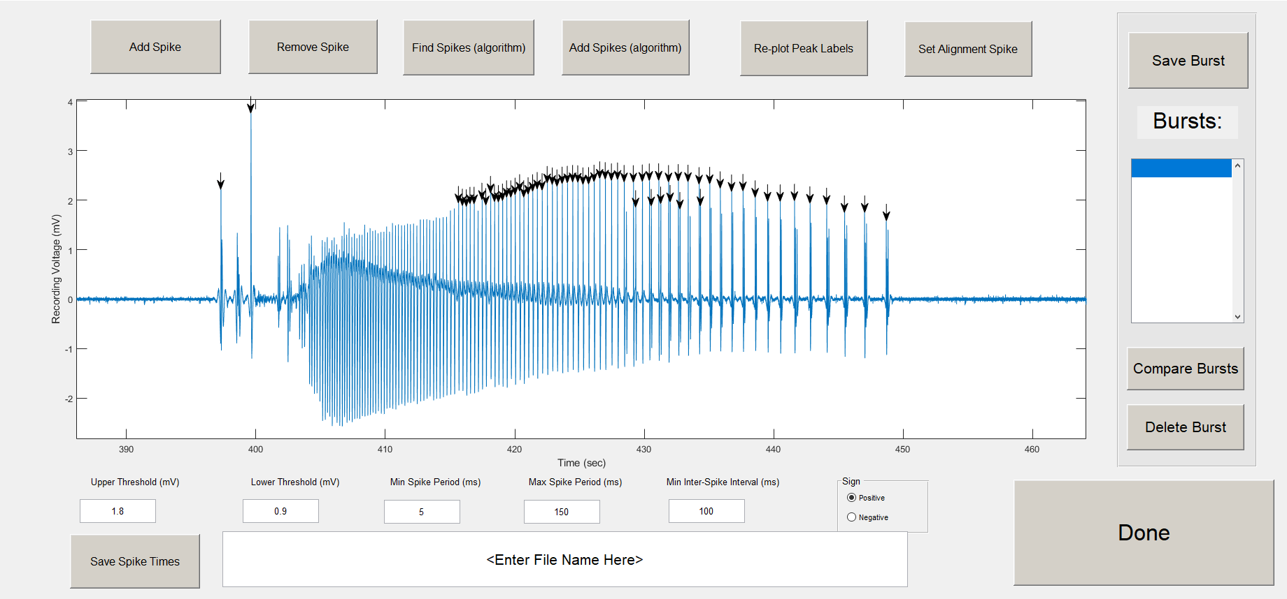

This could be useful if your waveform has both positive and negative spike times. You can find spikes with a sign of positive selected. Then, you can add spikes using a sign of negative.

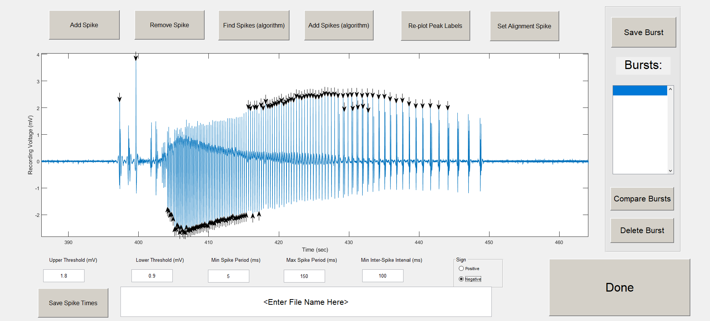

It is also useful if you want to keep the manually added spikes.

# Manually remove a spike from the GUI.

In our recordings, there was sometimes a ripple of spikes that occurred following a large population spike. The last spike of the ripple occurred more than 100 ms (the minimum inter-spike interval) later than the initial population spike. We chose to manually remove these spike times as we saw them linked to the main population spike rather than a separate spike time.

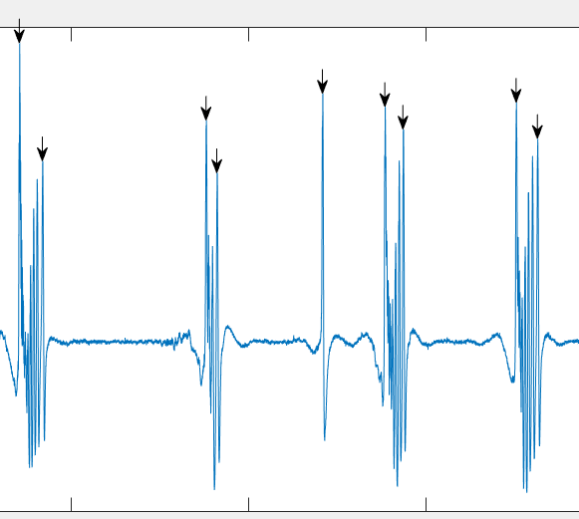

Click the remove spike button, mouse over the spike you want to remove, and click it. The peak arrow label will disappear.

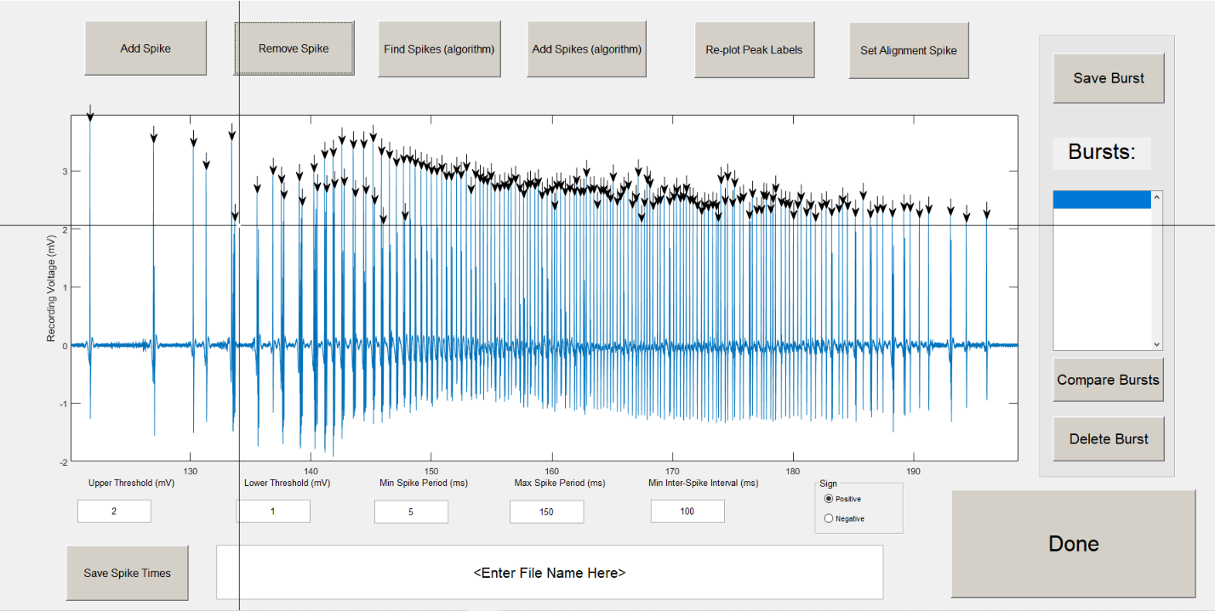

# Manually add a spike.

Sometimes a seizure population spike will occur, but the amplitude will not reach the upper threshold to be detected by the algorithm. The spike time can be manually added by clicking the add spike button. Be careful to select the exact timing and peak location of the spike. It will add a spike peak label wherever the mouse is clicked.

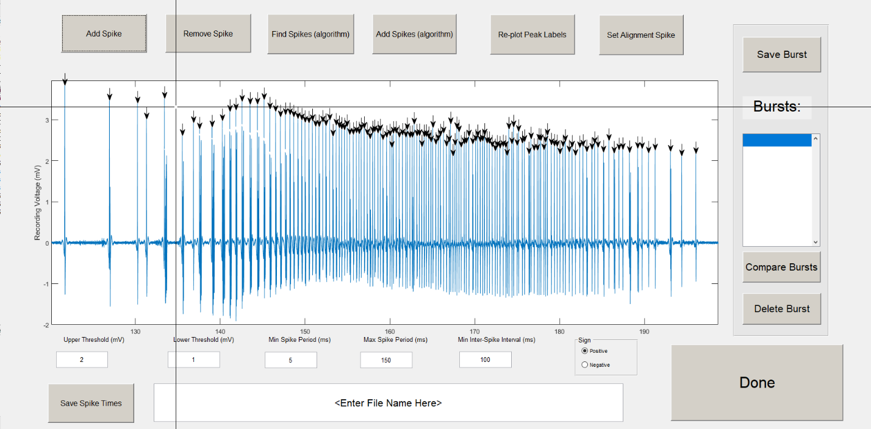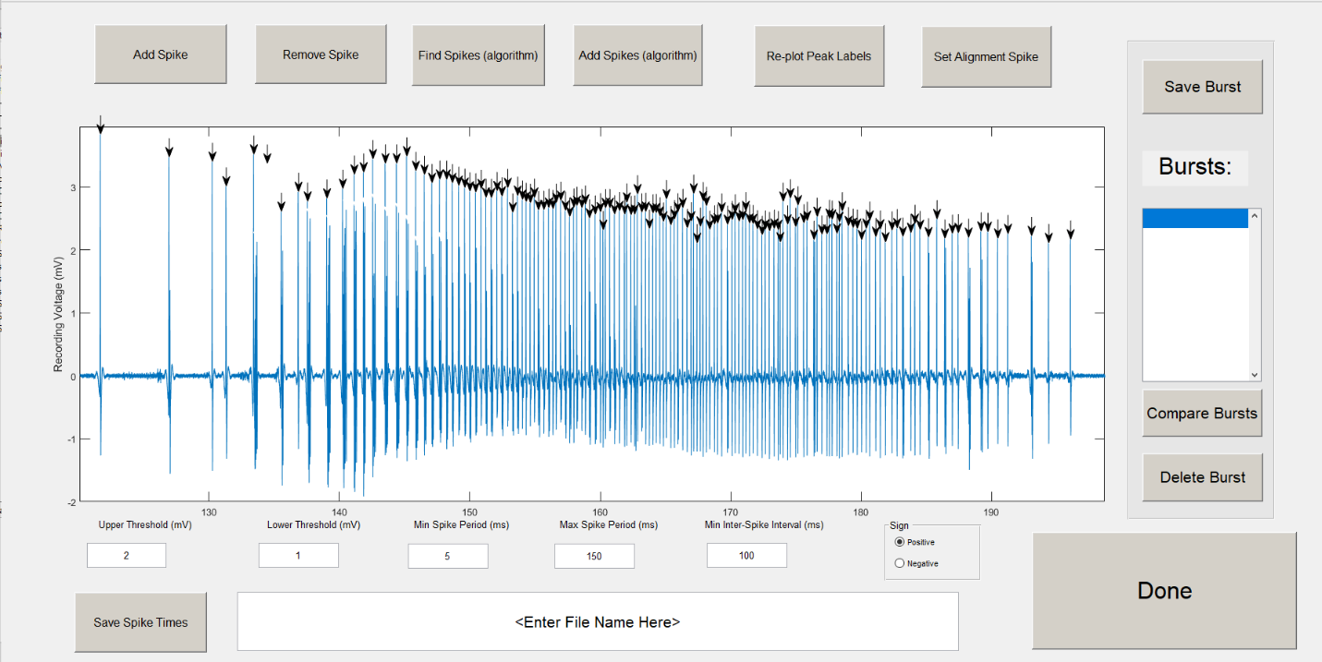

# Re-plot peak labels re-positions the labels to the correct data points. If you zoom out or zoom in, the peak labels will not zoom in or zoom out with the figure.

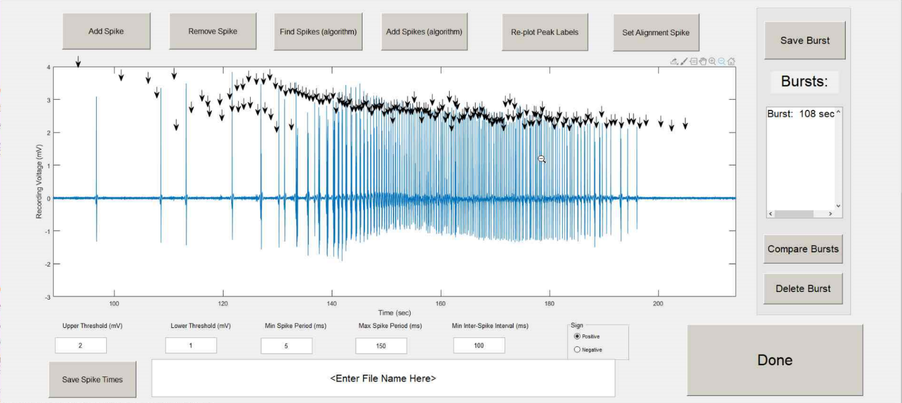

Pressing Re-plot Peak Labels corrects the

The labels can be correctly re-positioned by pressing re-plot peak labels.

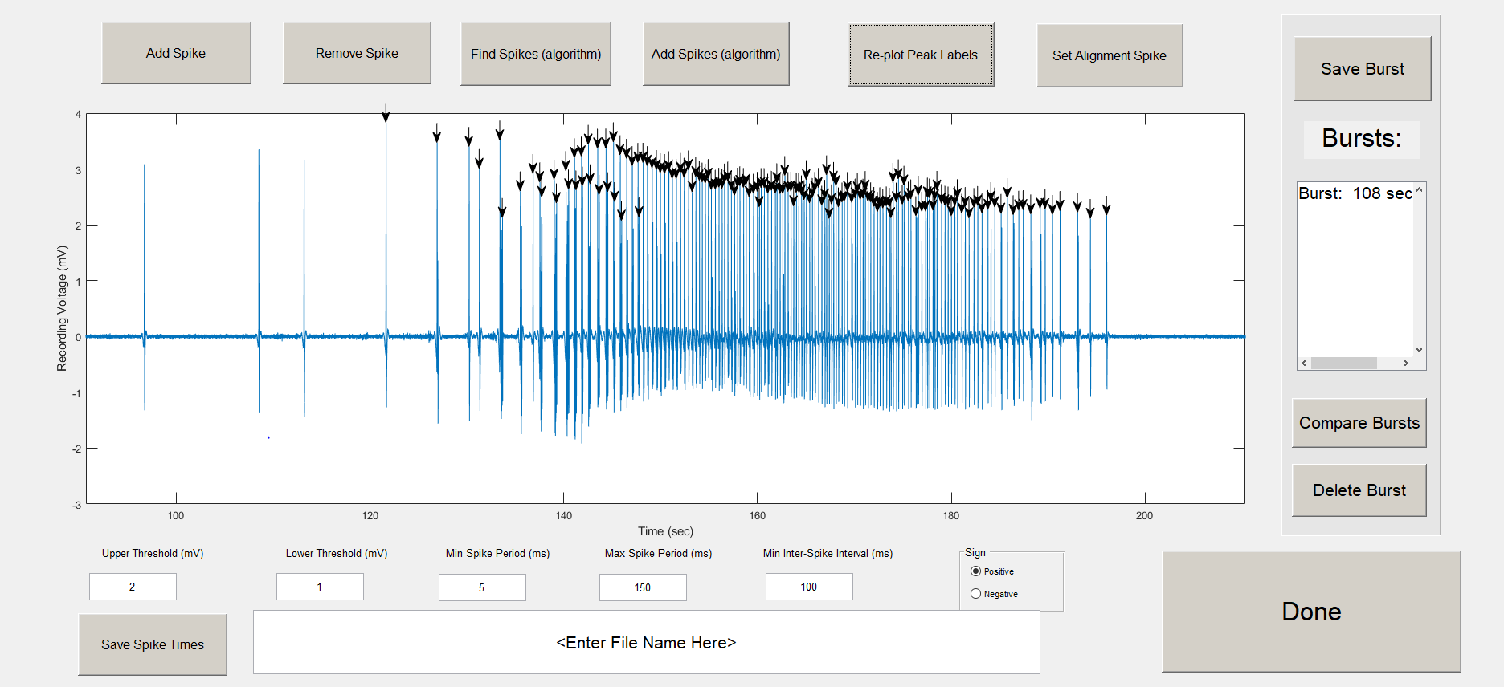

# Set an Alignment Spike

In order to perform jitter analysis, the waveform needs to be aligned with the other spike times. If you try to save a burst, a message box will appear that requires you to set an alignment spike before saving the burst.

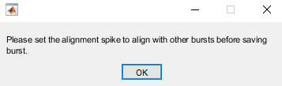

Click the Set Alignment Spike button, and select a spike on the chart. The arrow will turn red. You will now be able to save the burst.

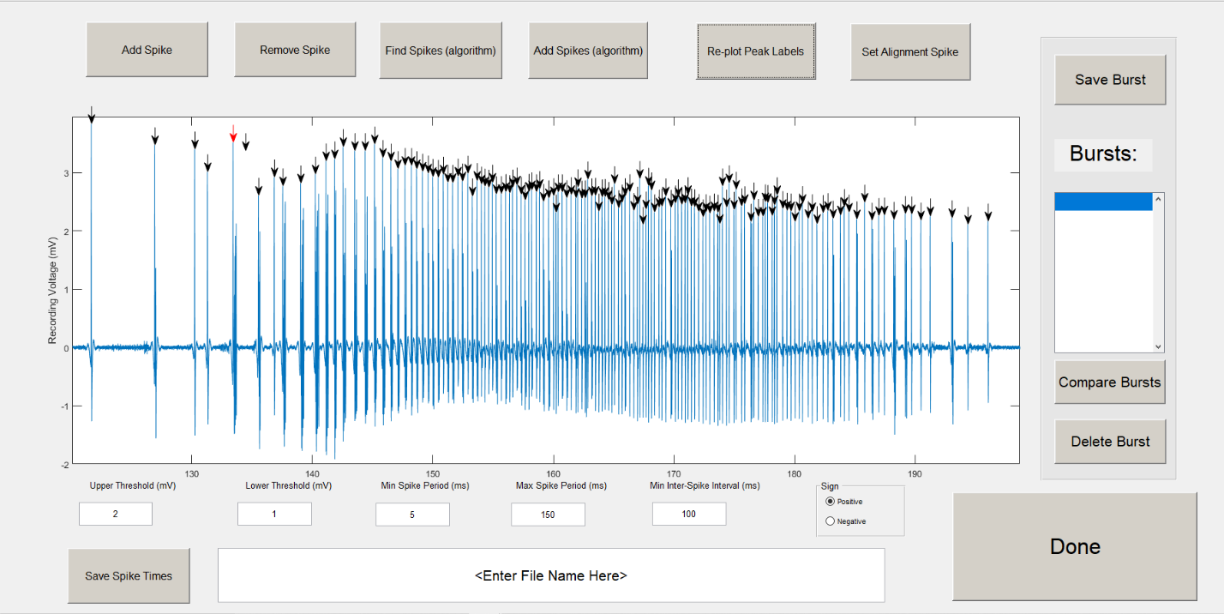

# Save Burst

To save the spike time data, click the save burst button. The burst is temporarily saved, and it appears in the list box. The peak labels will be removed from the figure, and you can continue finding spikes for a different burst.

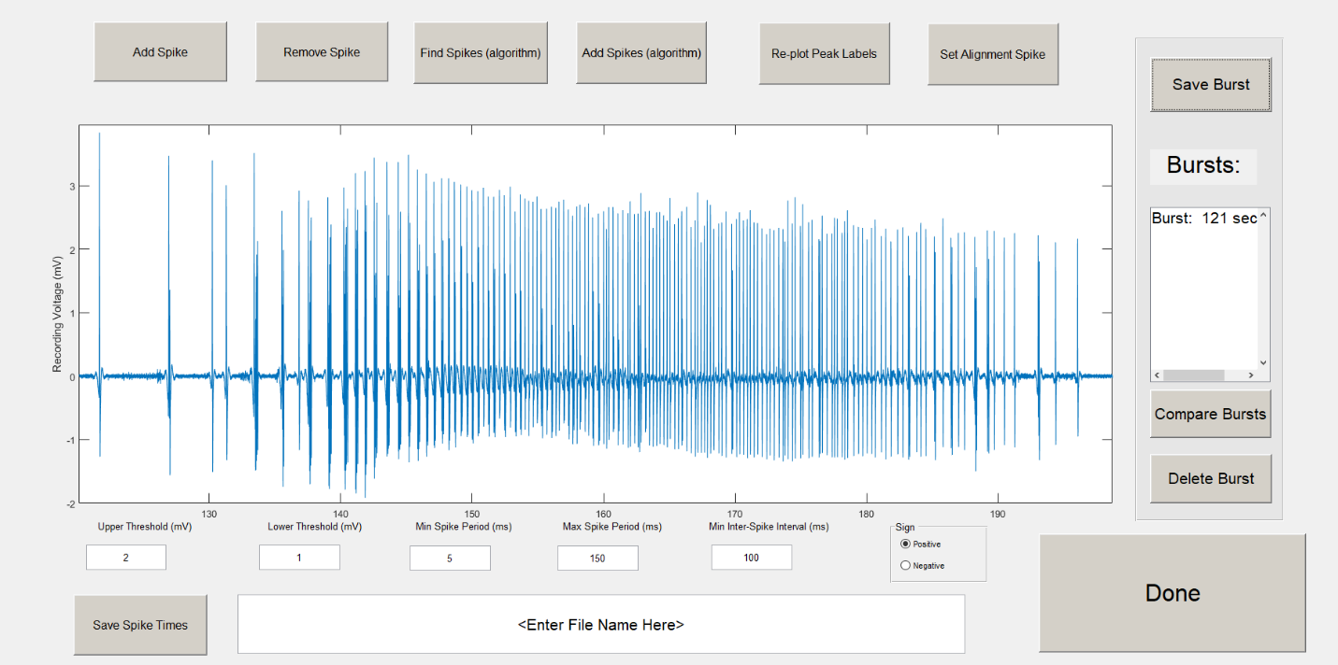

To distinguish bursts in the list box, the time of the first spike is displayed (above it shows “Burst: 121 sec”).

Note: If the figure window is exited, the spike time data will be lost. To keep the data, the save spike times button copies the data to an excel spreadsheet (see step 11).

# Compare Bursts

After multiple bursts have been saved, you can compare the spike time data of multiple bursts. Ctrl+click on multiple bursts in the list box to select them, and click the compare burst button.

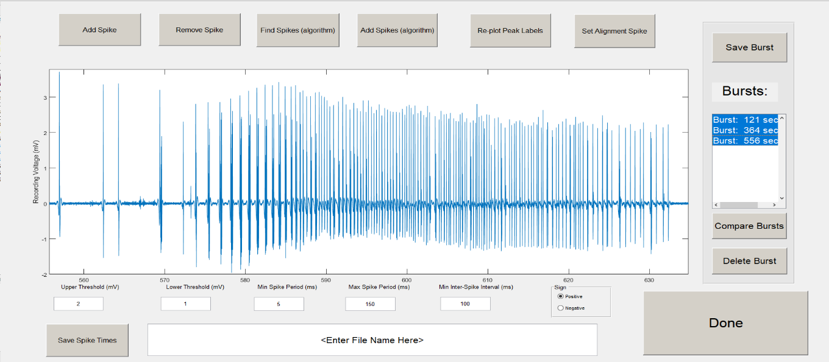

The selected bursts are shown in a figure window. It plots a maximum of 4 bursts in one figure window before creating a second figure. Below, there are three bursts aligned with the alignment spike.

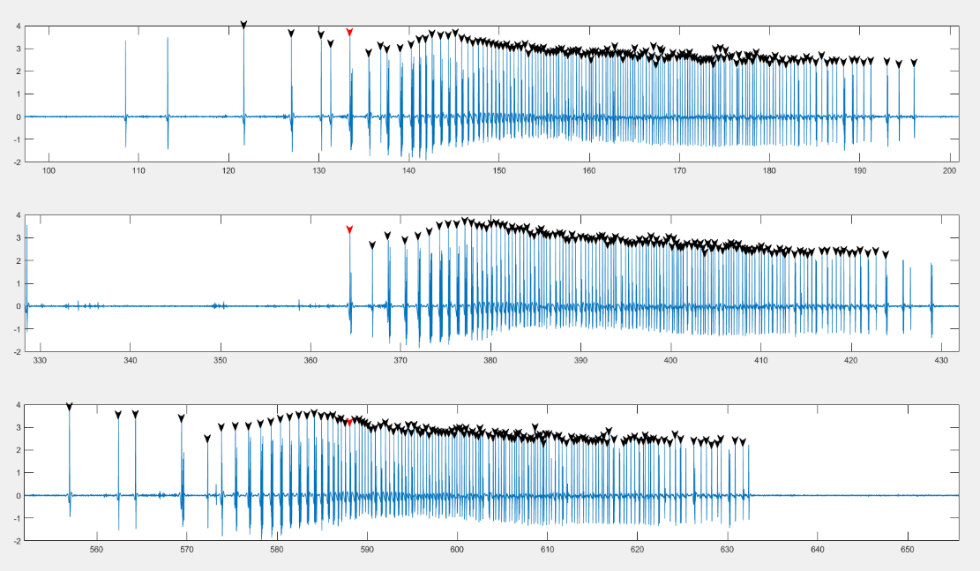

The last burst in the figure has an alignment spike that does not align well with the first two bursts. You can go back to that burst and edit it to pick a better alignment spike.

# Edit and Delete Bursts

To edit a burst, double click on a burst in the list box. The figure will zoom into the burst waveform and plot the spike time labels. The burst will also disappear from the list box. It is important to save the burst again even if you don’t make any edits to it. The data will be erased if you don’t save it and close the figure window or click the find spikes button, so you may want to save the data to an excel file before editing bursts.

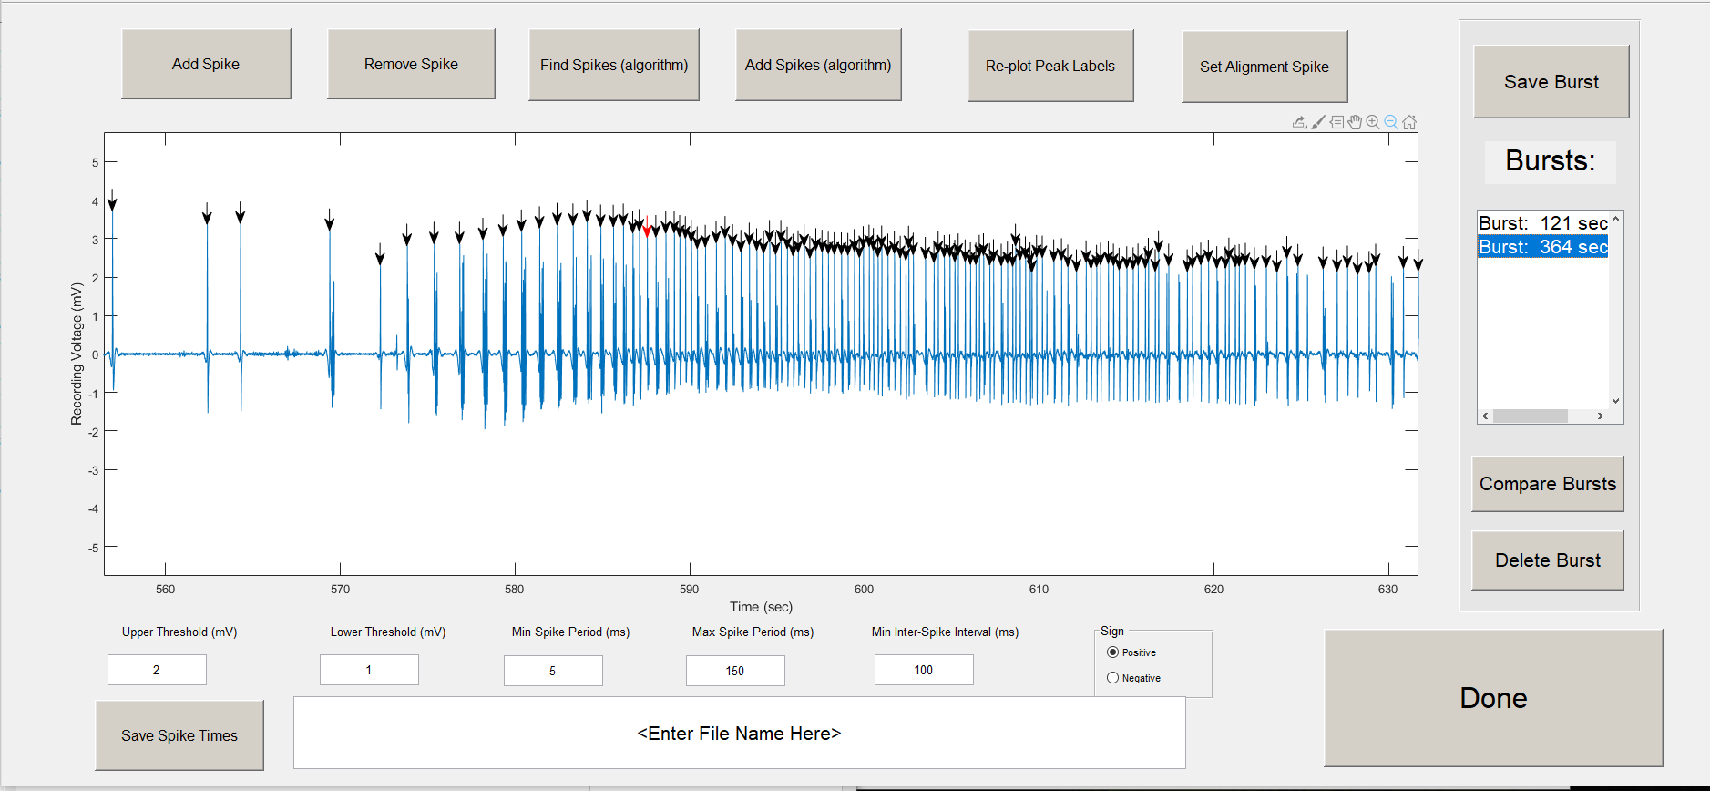

“Burst: 556 sec” from step 9, was double clicked. It is plotted to the figure window and removed from the burst list.

To delete the temporarily saved bursts. Click the “Delete Burst” button. It will be removed from the list box.

# Save Spike Times

To save your spike detection to an excel file. Type in a filename and click the save analysis button. By default, it will be saved to the same folder path as the MATLAB files. The path can also be specified in the file name (make sure file path exists).

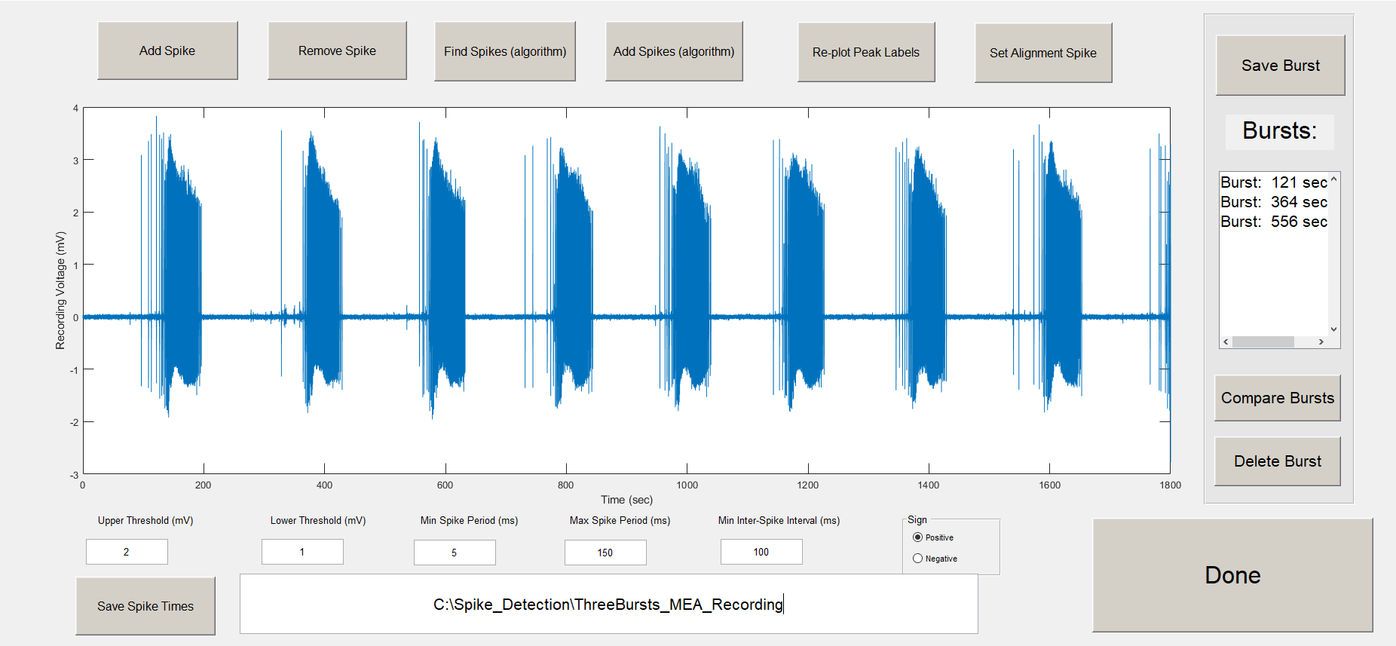

In the excel file, each sheet represents a new burst. Column A contains the spike times. Cell B2 contains the alignment spike.

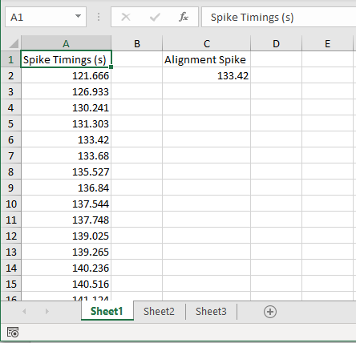

# Done

When you are finished with spike detection, you can close out the figure window or click done.

If you haven’t saved the spike time data to an excel file, a warning will appear.

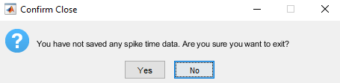

That’s it! See step 13 if you want to utilize spike times you already saved with the GUI.

# Run the spike detection GUI with already saved spike times.

If spike time data needs to be edited, an excel file can be selected before the GUI opens. First, run “Seizure_Detection_And_Jitter_Analysis_Main.m”, and select the .mat recording file.

A prompt asking for spike time data will appear. Click “Yes”.



A prompt will appear to browse to an excel file containing the spike time data.

Note: The excel file must have spike time data in column A and the align spike in cell B2.

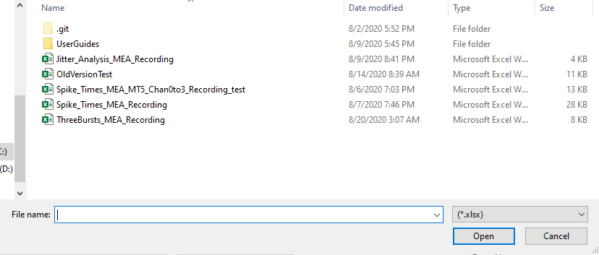

The GUI will load with the spike times saved in the list box. Double click the bursts to edit, or add new bursts to the data.

